ETSY, INC.  
BUSINESS MODEL, COMPETITIVE FORCES AND STRATEGIES CS782 ASSIGNMENT



SNEHA P

BOSTON UNIVERSITY

psneha@bu.edu

**ABSTRACT**

Understand the outline of how Etsy, Inc., an e-commerce company focused mostly on selling hand-crafted items, generates its money. The financial part of Etsy’s business model is distinctly appealing because the business gains a superior hold on percentage of trades. The business powers the creativity and determination of its sellers to ensure that shoppers can retrieve the products they are looking for, at the right moment. How can Etsy model an enduring competitive benefit in specialty retail?

September 12, 2021

**Table of Contents**

**INTRODUCTION** 1

**BUSINESS MODEL** 1

MARKET MODEL 2

FINANCIAL MODEL 4

OPERATIONAL MODEL 7

COMPETITIVE MODEL 8

**COMPETITIVE FORCES AND CHALLENGES** 9

RIVALRY OF THE COMPETITORS 9

THREAT OF NEW ENTRANTS 9

THREAT OF NEW SUBSTITUTES 9

BARGAINING POWER OF BUYERS 9

BARGAINING POWER OF SUPPLIERS 10

**COMPETITIVE STRATEGIES** 10

COST LEADERSHIP 10

DIFFERENTIATION 10

INNOVATION 11

GROWTH 11

ALLIANCE 11

PEST ANALYSIS 11

**BUSINESS MODEL EVOLUTION** 11

**BEST IT-SUPPORTED PROPOSAL** 12

**CONCLUSION** 12

**REFERENCES** 12

Figure 1: Latest data on Etsy.com marketplace1 1

Figure 2: Etsy climbs the ladder2 3

Figure 3: Buyer segments of Etsy.com3 4

Figure 4: Quarterly financials4 5

Figure 5: Annual financials4 5

Figure 6: Marketplace vs Services Revenue6 6

Figure 7: Owners of Etsy, Inc.7 7

Figure 8: Etsy's business model summarized8 8

Figure 9: Etsy Alternatives9 9

Figure 10: "Right to Win" Strategy10 10

# **INTRODUCTION**

Etsy, Inc. (Etsy) profits from competitive advantages generated by a dual-purpose system, which means sellers and shoppers draw one another to the program. When there are demands, it generates supplies; when there are supplies, it generates demands. According to InvestorObserver, Etsy receives an all-time rating of 74 that implies the percentage of stocks it scores is 74% or higher. What strategy does Etsy use to retain its handmade marketplace? How does it compete with its competitors such as Amazon, eBay, and AliExpress? This report will analyze the business model, competitive forces, and strategies adopted by Etsy, Inc. which helped the business thrive into a giant e-commerce company.

# **BUSINESS MODEL**

Etsy, Inc. is a publicly traded e-commerce company founded in 2005 and has its headquarters in Brooklyn, New York. The company claims to have over 800 employees who work full-time. The company’s primary marketplace is *Etsy.com* which is a universal market for rare and creative products tying artists and entrepreneurs with considerate customers. According to Etsy’s fact sheet, the company incorporates three more marketplaces: *Reverb, Depop,* and *Elo7*. *Reverb* is a marketplace for musical instruments, *Depop* is a marketplace that comprises reselling fashion items, and *Elo7* is a marketplace based in Brazil for hand-crafted products.

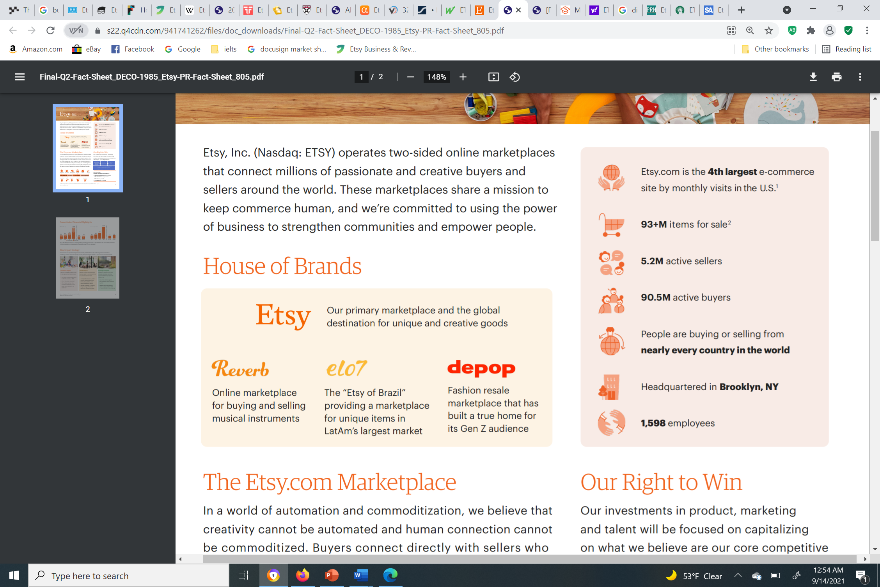

Figure : Latest data on Etsy.com marketplace1

The company has Improved search results are a high-tech triumph for Etsy, and more and more a financial victory too. Etsy.com has 60 million goods available for purchase at any moment, be it ordinary products or eccentric products. The business was initiated in 2005 and its followers are obsessed for its “Keep Commerce Human” slogan, coupled with its emphasis on small-scale sellers over big commercial firms. (Wahba, 2019)

The following sub-categories of the business model will analyze how Etsy, Inc. generates profit.

## MARKET MODEL

Etsy, Inc. is a product-based company, occupying the e-commerce industry segment, which provides handcrafted products in categories like jewelry, toys, art & collectibles, apparel, and much more. Etsy has familiarized itself with means to generate as well as acquire massive value due to several reasons. Some of the reasons are listed below:

·       The company’s marketing model is somewhat the same as that of its competitors: Amazon, eBay, Alibaba Group Holding Limited, etc., but with a focus on a niche market that emphasizes mainly specialty products. This makes its marketplace the no.1 destination for consumers looking for unusual, exclusive goods. Etsy attracts prospective customers looking for expressive everyday items or special occasion items all year long. Etsy also provides services such as prepaid shipping labels, product bumps, and other services to the sellers.

·       The company establishes value to both its buyers and sellers; sellers are given an opportunity to showcase their skills and make a living through their products while buyers gain access to a plethora of creative products which may not be found in any other marketplace. Furthermore, Etsy’s algorithm provides suggestions to buyers related to the product are buying or searching. Etsy has sellers and buyers from around the world.

Etsy.com is a marketplace that focuses on producing unique goods that are either personalized or standardized. For someone looking for a sleeping pouch for their pet hedgehog, some sellers can offer pouches in different materials, sizes, and colors. Sellers can also add a personal touch by sewing the name of the pets on the pouch.

**Product positioning**

Etsy is a pioneer for selling vintage and hand-crafted products exclusive to its platform. Etsy provides a great platform for a busy circle of designers, artists, and craft persons to sell their products. The company accelerates the idea of supporting small businesses worldwide. Amazon and eBay list about every kind of item, but Etsy lists exclusive items. Etsy caters to lesser traffic compared to Amazon, thereby increases the visibility of products. A seller on Etsy.com is more likely to get recognition from its customers than a seller on Amazon.com. On Amazon.com, customers most likely shop by price and reviews whereas, on Etsy, people notice the creativity or uniqueness of items being sold by a certain seller. However, reviews still play a big role on any platform.

**Value propositions**

While Amazon may also contain some hand-crafted products on their Amazon Handmade platform, Etsy seems to be the brand name that comes to most customers’ minds when they want to buy anything distinctive and crafty. Many customers today tend to purchase goods from small businesses over commercial large firms; thereby, creating a sense of community.

**Market positioning**

Sarah Coop, Thematic Analyst at GlobalData, comments: “Etsy has jumped to the top of GlobalData’s Ecommerce Thematic Scorecard, benefitting from Depop’s GenZ consumer base and social media expertise.” Figure 1.2 displays GlobalData’s Ecommerce[1] Thematic Scorecard; Etsy scores 5/5 in COVID-19 and sustainability, which implies the company handled the challenges surrounding the pandemic as well as advanced in sustainability initiatives. The company also scores highly in social media, mergers & acquisitions (M&A), regulation, and digital payments.

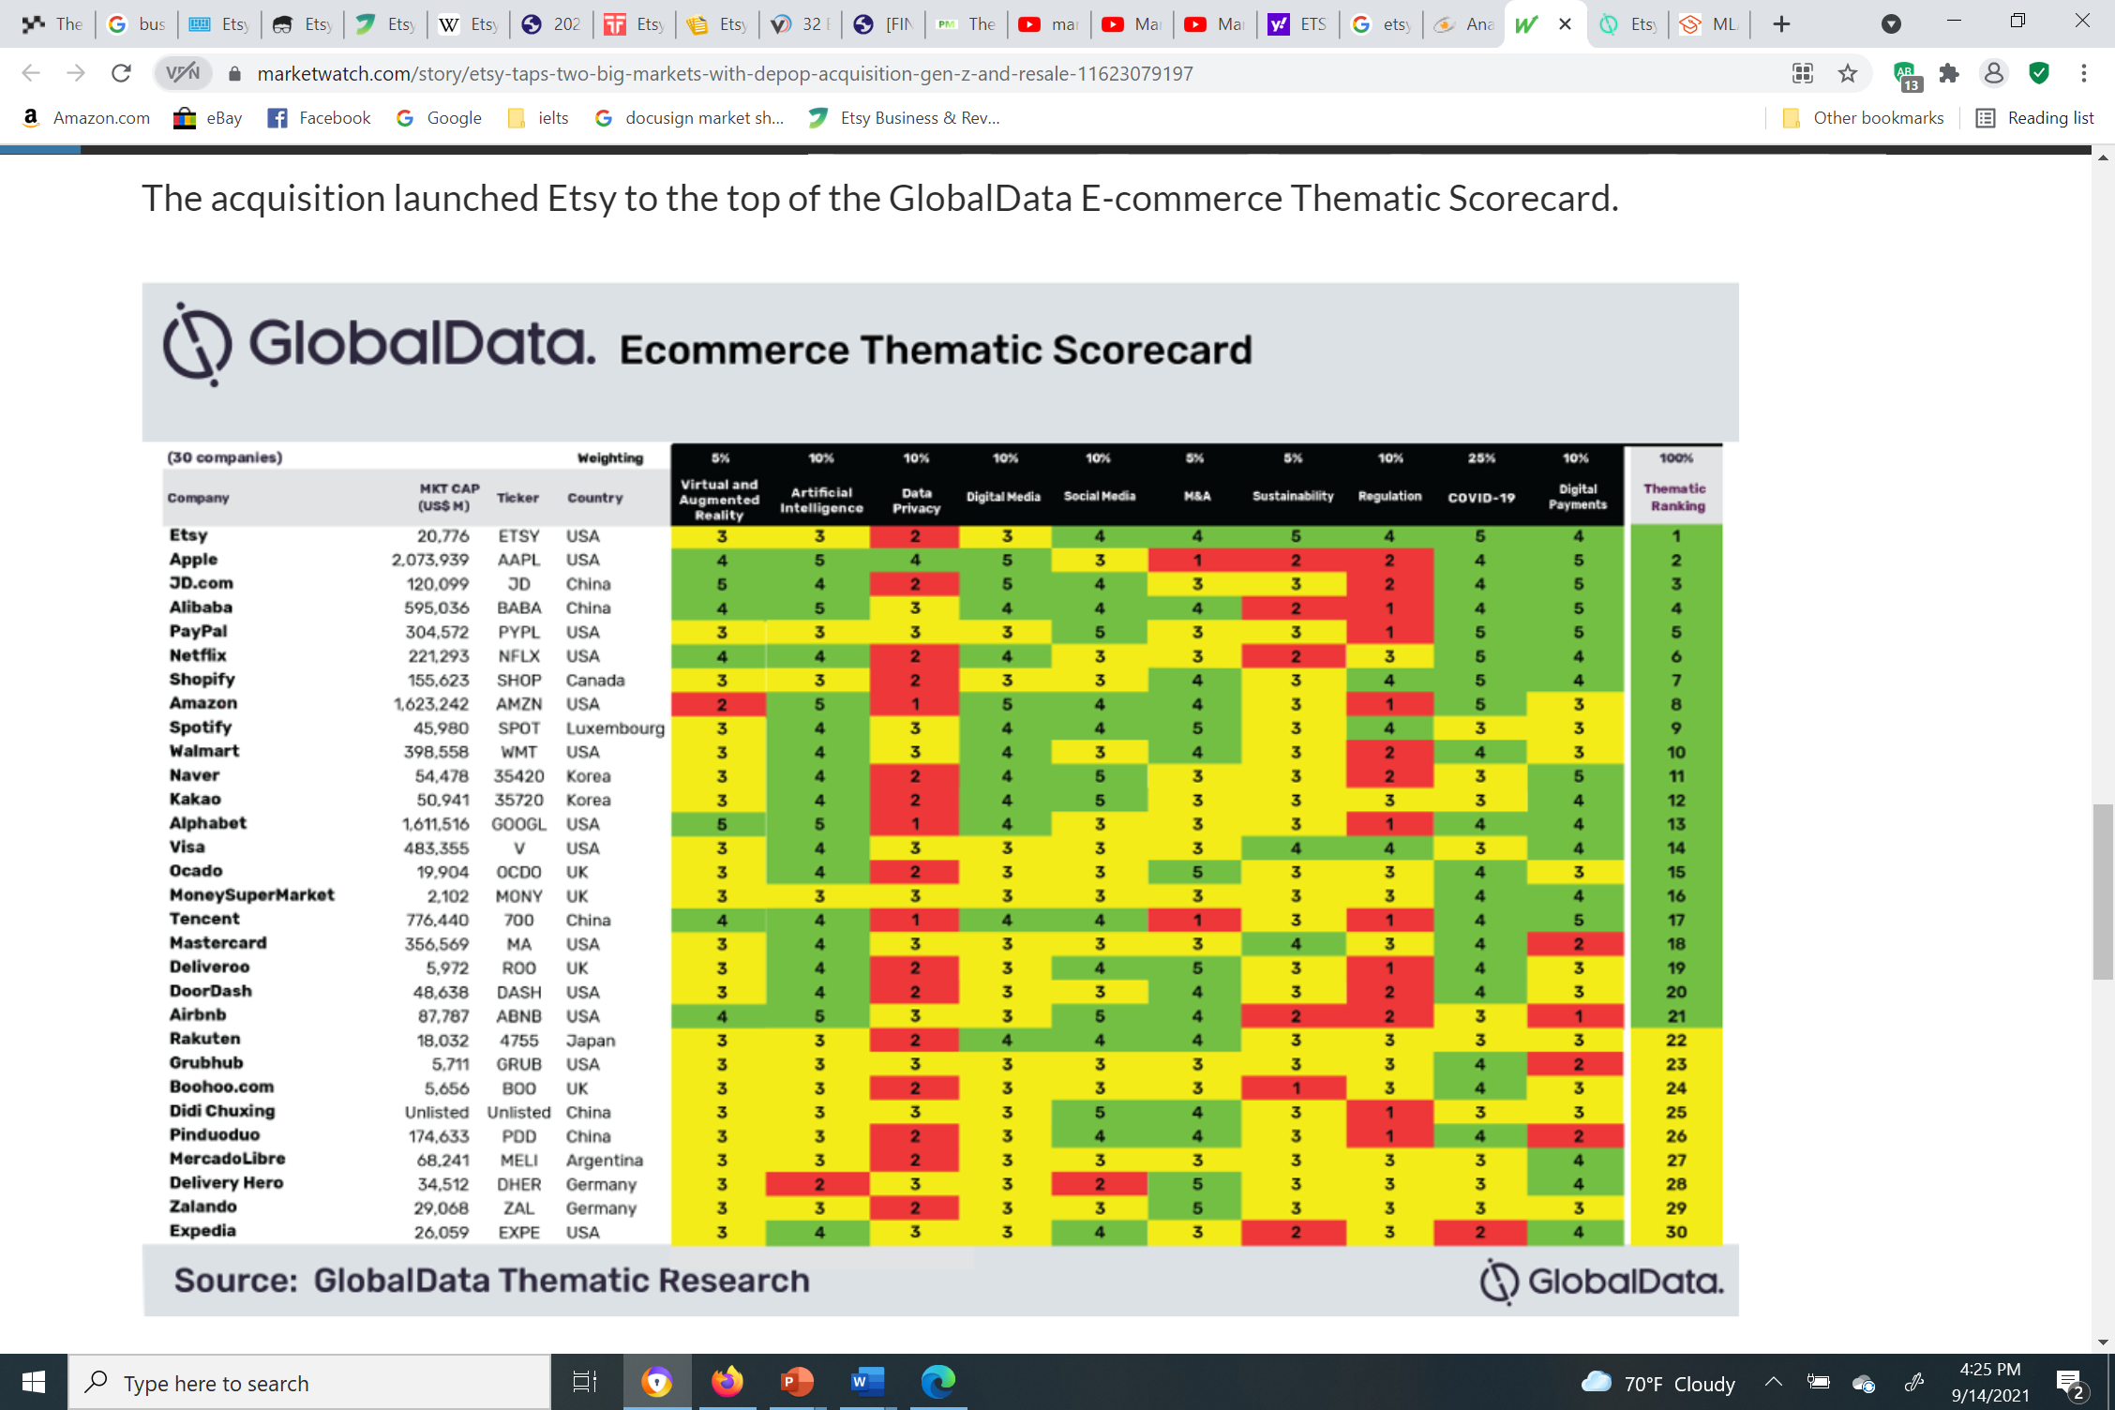

Figure : Etsy climbs the ladder2

An article in Digiday states the fundamental principles that occur at the heart of the Etsy brand attract two types of buyers: the buyer who hunts for items that are rare in a retail sea of mass manufacture, and the buyer who would rather support a small business over a large firm. (Milnes, 2015) Many customers who shop on Etsy are return customers because they have been offered a great experience. Additionally, Etsy sends out promotional emails (discounts or credits) to current customers which draws the customers to browse products on the marketplace and possibly purchase a product. Sellers on Etsy.com are offered on-site and off-site ad programs. In off-site advertising, the seller's product will pop up a[2]s a search result when searched on popular search engines like Google and social media platforms like Facebook and Instagram.

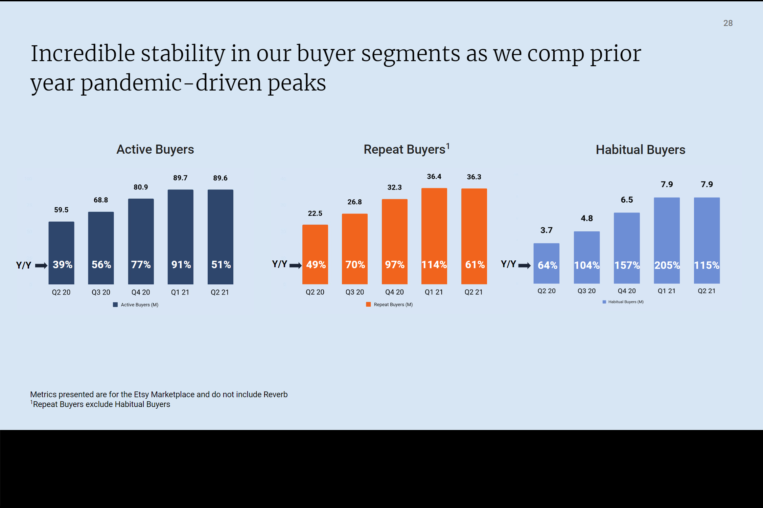

Figure : Buyer segments of Etsy.com3

## FINANCIAL MODEL

From Yahoo! Finance, the following details can be noted as of September 14, 2021.

Yearly revenue: 1.73B

Earnings: 349.25M

Profit margin: 20.2%

EBITDA (TTM): 567,701

Market Cap: 27.127B

Cash flow and cash position (TTM)

Operating Cash Flow 699,023

Investing Cash Flow -114,314

Financing Cash Flow 783,095

End Cash Position 2,050,669

The following chart from Yahoo! Finance summarizes how much Etsy has grown since 2017. In 2017, the company generated revenue of 441.23M and 81.8M in earnings; while, in 2020, the company generated revenue of 1.73B and 349.25M in earnings.

[3]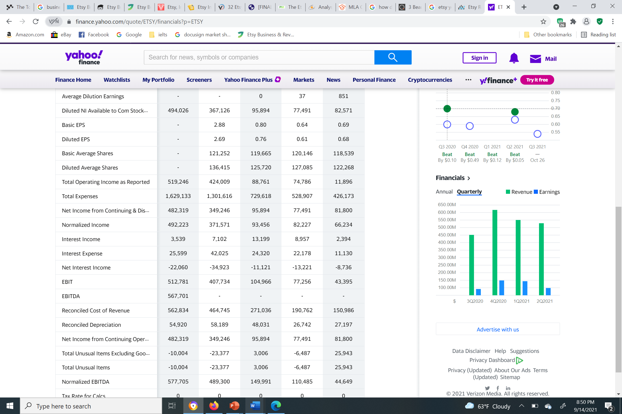

Figure : Quarterly financials4

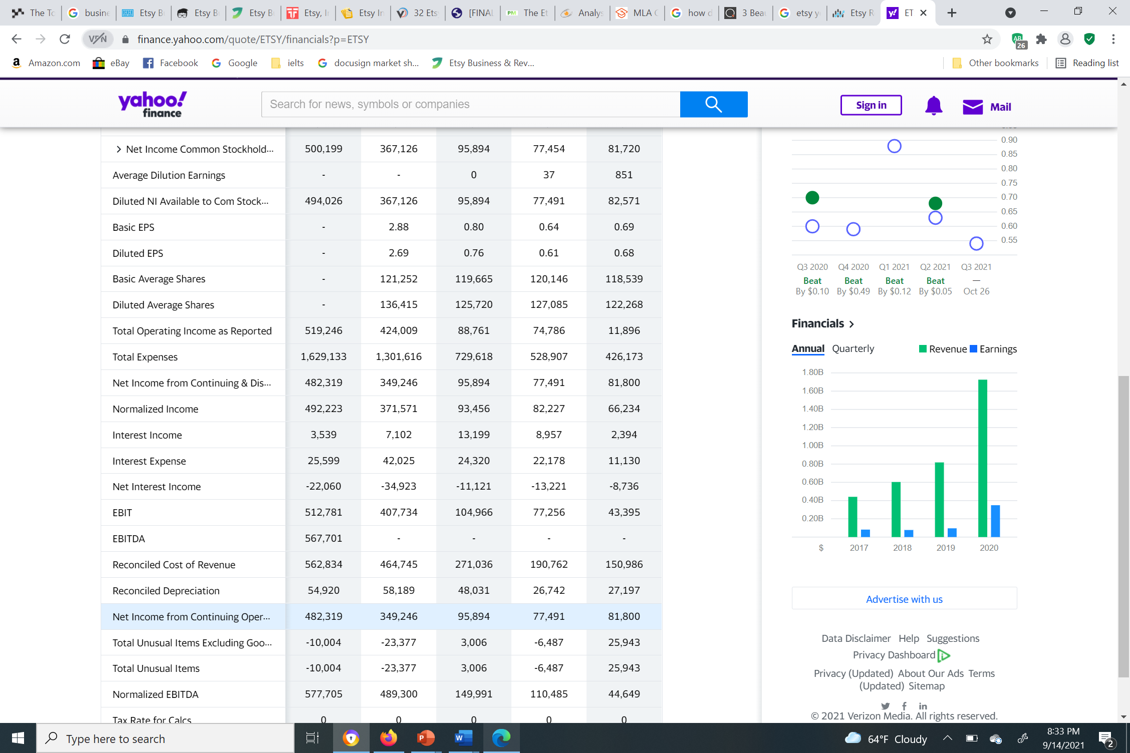

Figure : Annual financials4

Quarterly analysis (June 30, 2021): Etsy generated revenue of $0.529B, grew by 23.36% year-over-year (YoY). Annual analysis (TTM): Etsy generated revenue of $2.148B, grew by 91.01% YoY.

Etsy generates revenue through the following streams:

* *Fee for listing an item*: When sellers upload an item, they are charged $0.2 per listing which will be effective for a period of 4 months. The charge is applicable for every product in a listing. For example, if there is a listing selling a hat and there are 10 hats in quantity, the seller will be charged automatically for every hat sold.
* *Ads*: Sellers can choose to advertise their products by purchasing their ad campaigns.
* *Commissions*: Additional to listing fee, there is a transaction fee, Etsy earns 3.5% on the total amount a seller gains after selling a product.
* *Subscriptions*: Etsy charges $10 subscription fee to users who upgrade to Etsy Plus, which offers premium tools to handle their goods and shops.
* *Payment method*: Etsy charges its seller a fee depending on the type of transaction. The fee is only charged to sellers qualified to use Etsy Payments.
* *Pattern*: Etsy offers a tool that allows users to develop their own website to sell their goods online. Users are charged $15 after initial trial of 30 days.
* *Foreign exchange:* Etsy takes a cut of 2.5% on the total amount in the name of currency conversion.

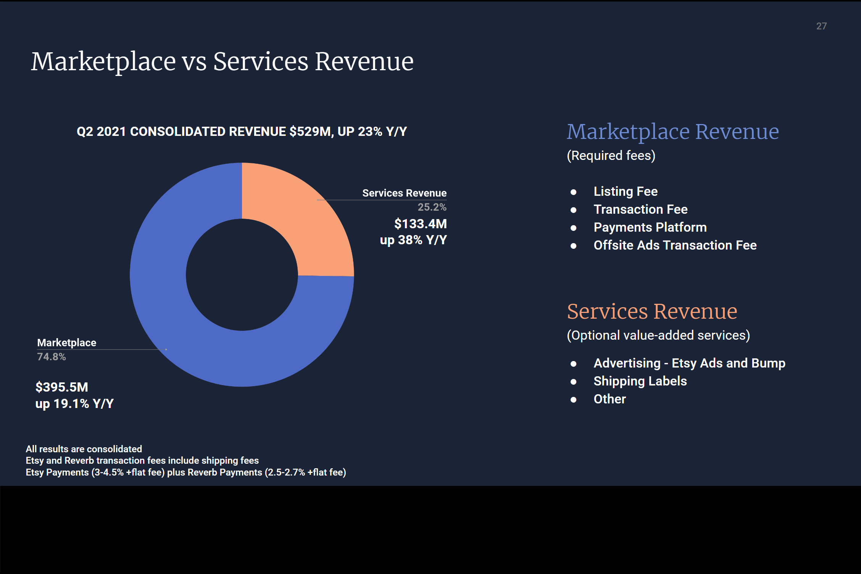

Figure : Marketplace vs Services Revenue6

The following image from CNN Business shows the top 10 owners of Etsy, the number of shares they hold, and the percentage of stake they have with the company.

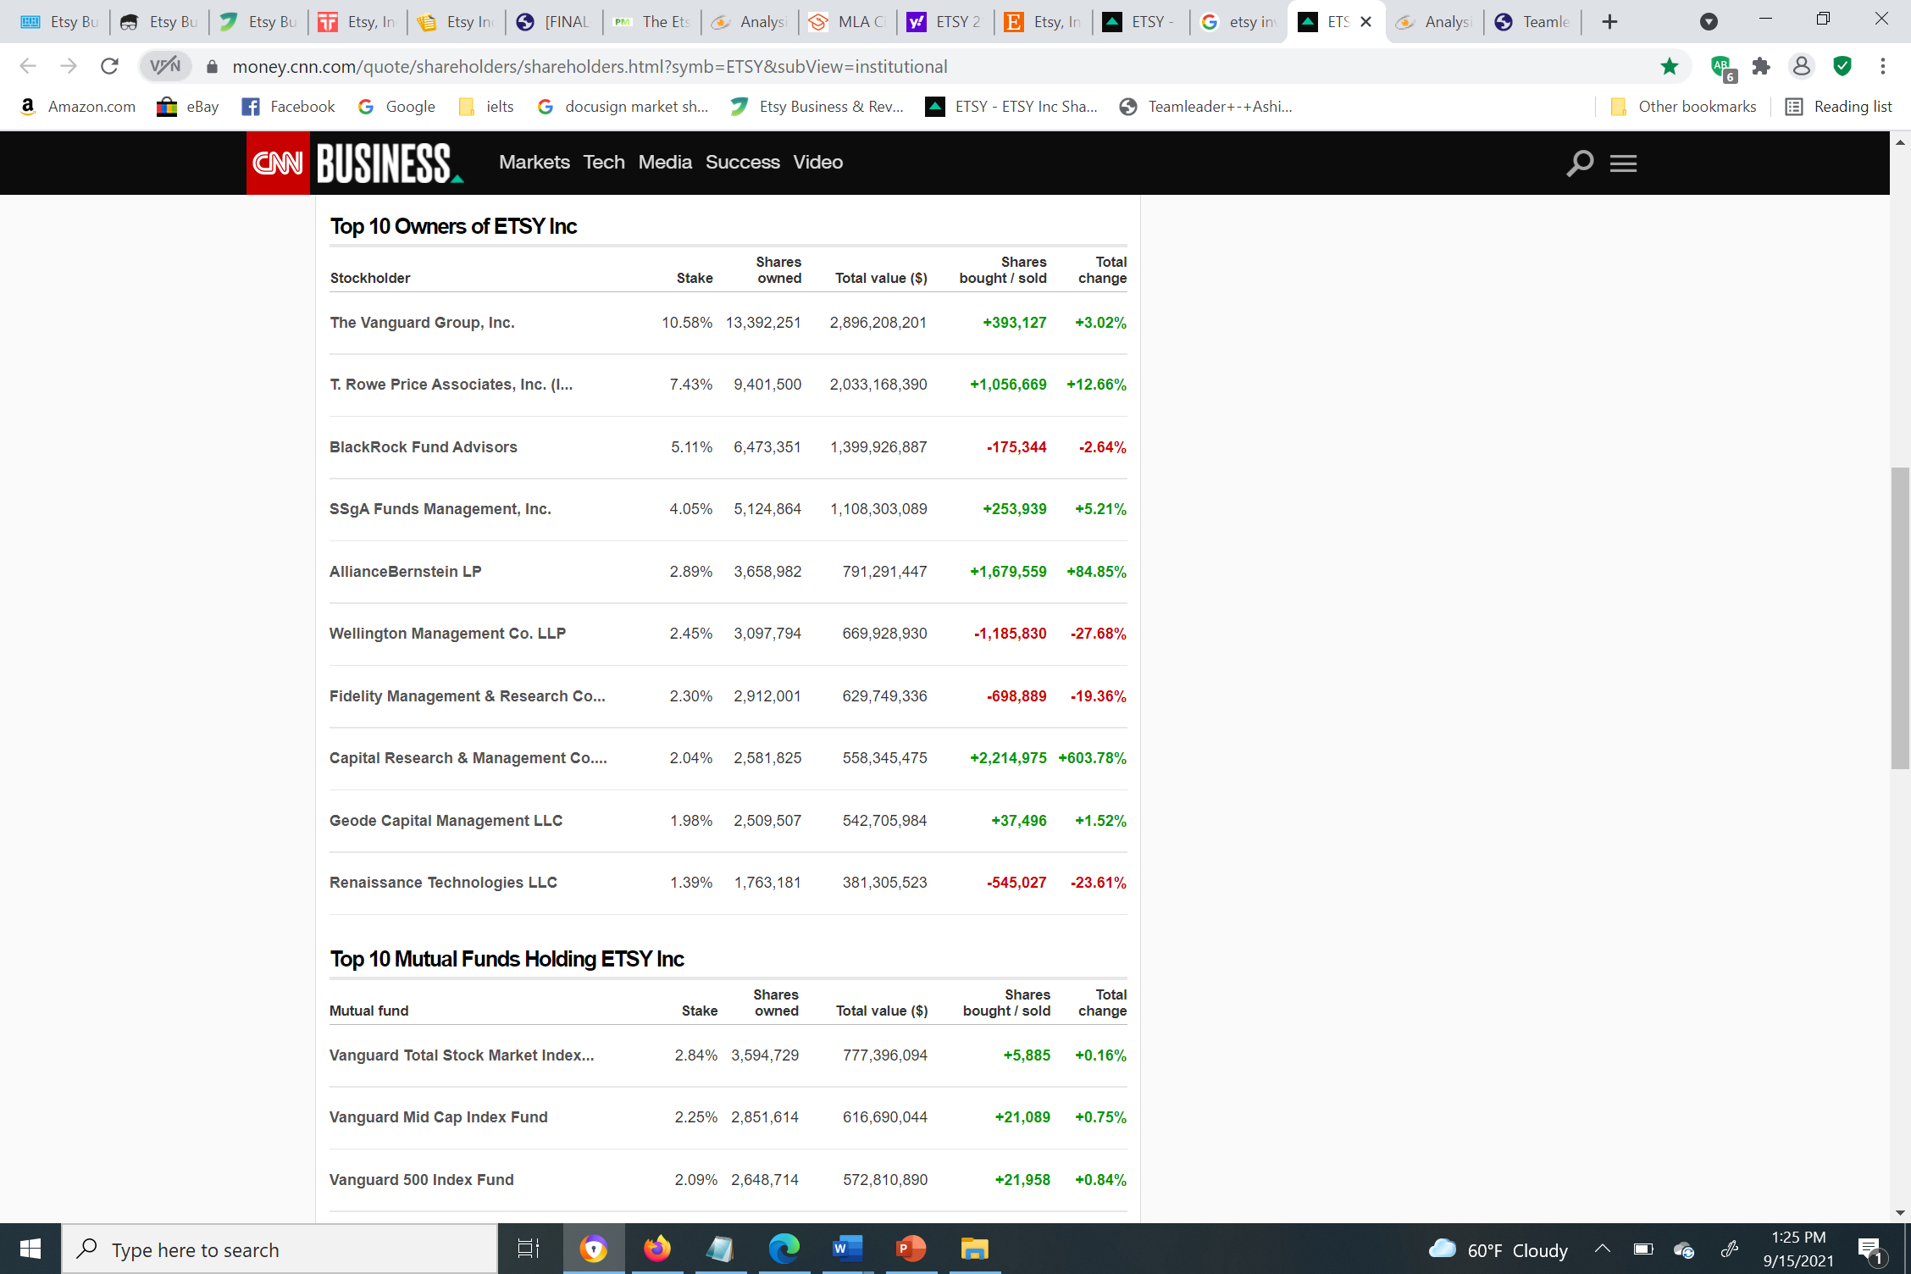

Figure : Owners of Etsy, Inc.7

Ets[4]y’s Intellectual Property Policy states: “As a venue for artists, designers, and makers, Etsy takes intellectual property rights very seriously. We comply with intellectual property laws and industry best practices to maintain the integrity of our creative marketplace. This Intellectual Property Policy explains how we address allegations of infringement, how authorized parties can submit proper notices of infringement regarding content on our marketplace, and how Etsy sellers can respond when their listings or shops are affected by a notice.”

## OPERATIONAL MODEL

On LinkedIn, the company mentions it has about 1000 – 5000 employees and the company’s headquarters is in Brooklyn, New York. The company has several delivery channels: its website, Google or Bing search, social media, etc. Etsy.com is a marketplace that is operational worldwide, Depop.com selling pre-owned clothes, based in London, is being recognized in other countries, and Reverb.com sells musical instruments (both new and used). The sellers organize the goods in their individual shops and ship the goods to the buyers. All of Etsy, Inc. marketplaces have a compliance policy that regulates if the goods being listed are in fact compliant. The legal team takes care of this and the regulation policies in different countries. The company also has several teams to review a seller and the goods they are listing. Customers can report a shop or a listing if there’s an issue with the order, and their team will investigate. For issues related to refund, buyers have the option to chat with sellers directly. If the issue is not resolved by the seller, the buyer can file a case and Etsy will try to resolve the issue by acting as a mediator between the buyer and the seller.

## COMPETITIVE MODEL

Etsy beat[5]s its competitors with its relatively accurate search results. For any given product, there is more inventory of handcrafted items on Etsy than on its competitors’ platforms. Although many of its competitors are entering this niche market, Etsy still beats them with its exclusive culture and brand recognition. Etsy is perceived as the edge of the disseminating economy; buyers are buying items that are not essential and suppliers are mostly using the platform as a source for passive income. The company follows an agile model which largely profited from COVID-19. Etsy also profits from social media influencers who are either sellers or buyers. Sellers can link their Etsy shop in their social media bio and buyers can promote the products or shop on Etsy.

**Cloud computing:** Recently, Etsy transferred its e-commerce platform and data center to Google Cloud where it gets to utilize the robust tools offered in Google Workspace.

The following figure summarizes the business model of Etsy.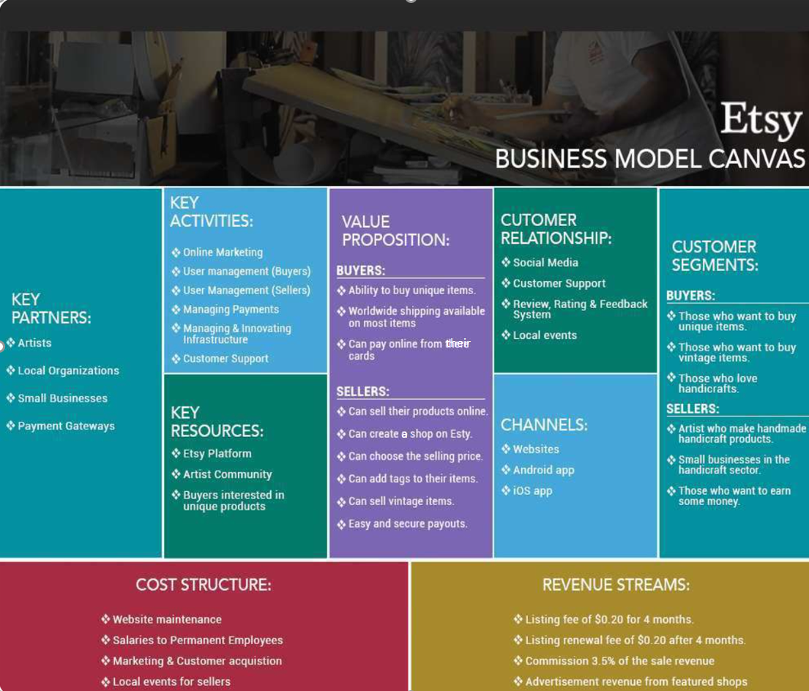

Figure : Etsy's business model summarized8

# **COMPETITIVE FORCES AND CHALLENGES**

## RIVALRY OF THE COMPETITORS

Amazon Handmade, eBay, Bonanza, AliExpress, Wish, and Flipkart are some of the biggest competitors of Etsy. All these companies constantly battle for market shares. There are more competitors who serve as great alternatives for Etsy sellers as shown in the following image.

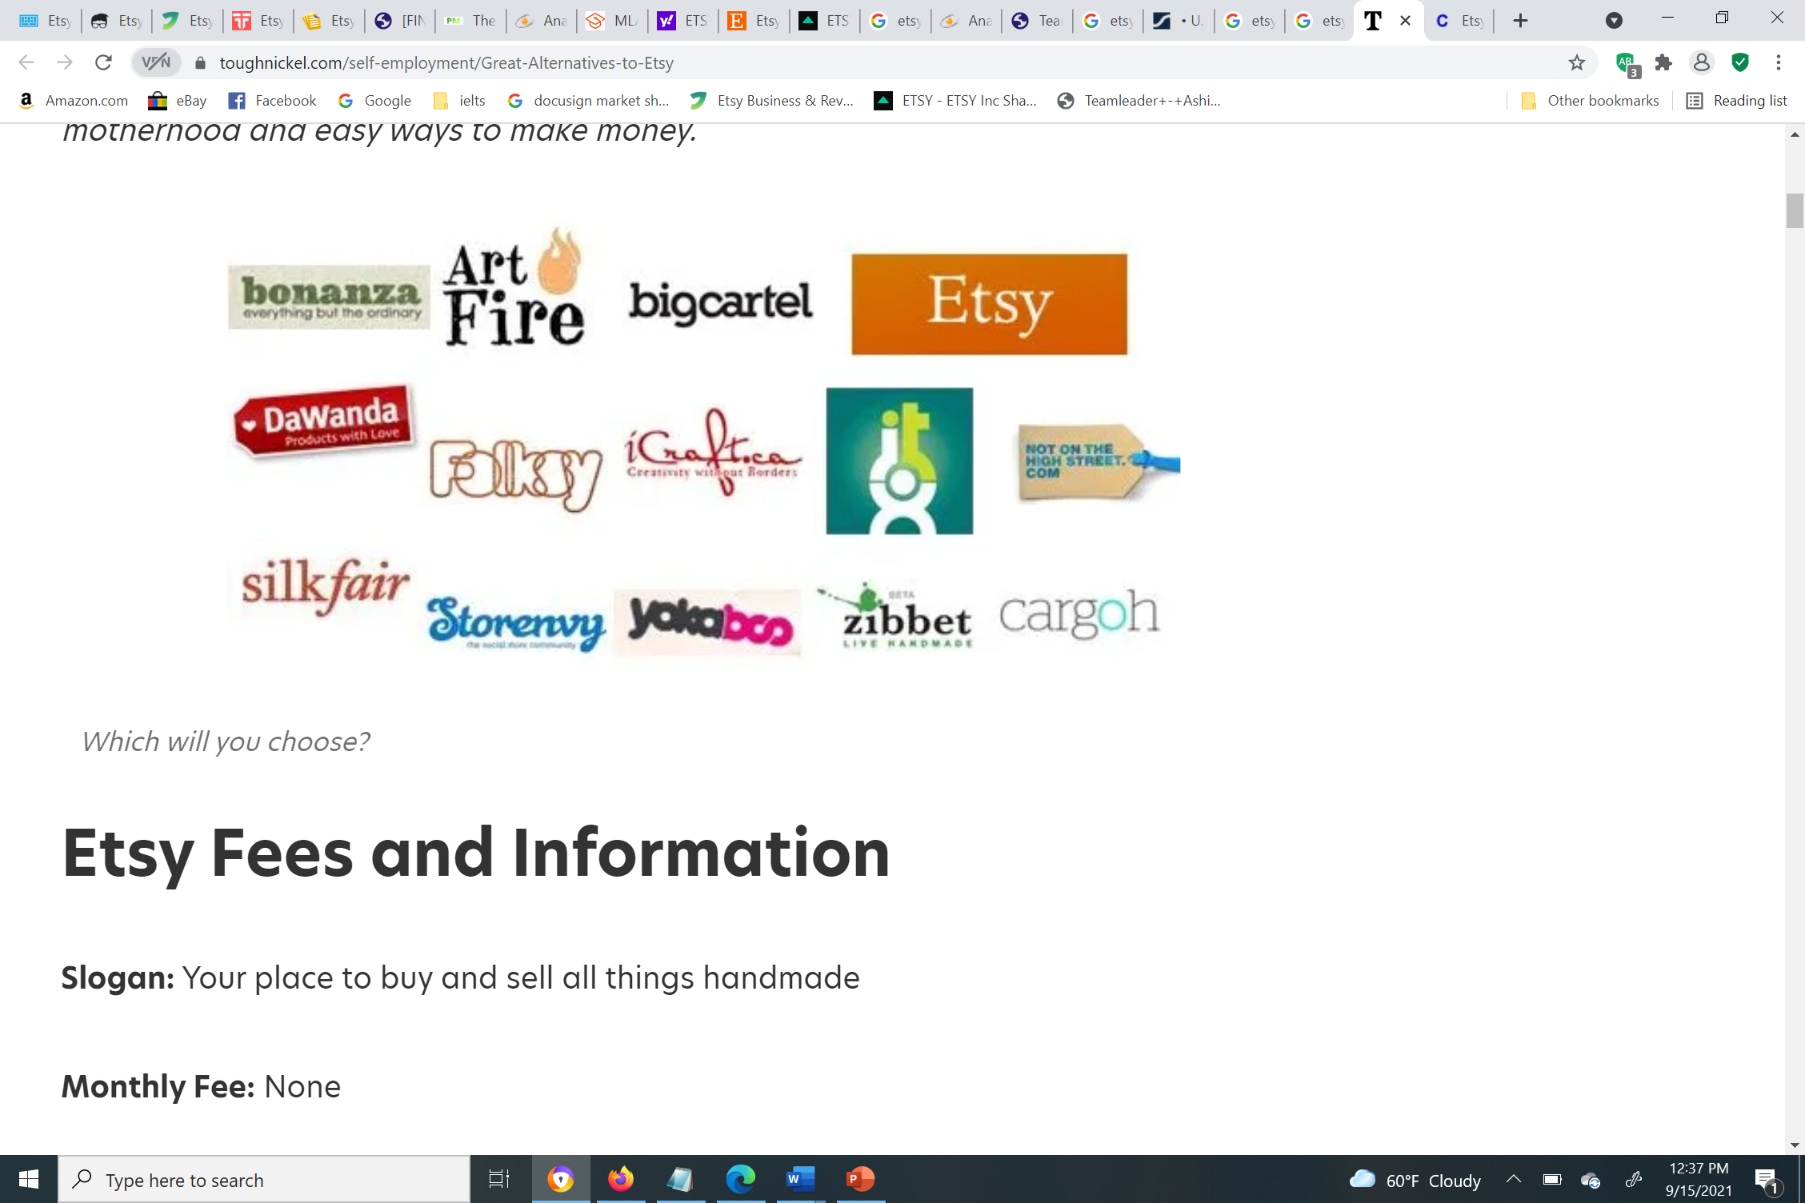

Figure : Etsy Alternatives9

## THREAT OF NEW ENTRANTS

The threat of new entrants is high as companies like Amazon and AliExpress have already entered the industry and are offering similar services provided by Etsy, Inc. Anyone can start an e-commerce business as it does not require much investment. There is a potential risk of competitors offering better services to sellers like not having to pay listing fees or commission. A competitor like Amazon can offer faster sh[6]ipping and easier return/ refund programs. If the competitors offer the same services and goods offered by Etsy in a more efficient and cost-effective way, customers may transition from Etsy to other businesses. Furthermore, the newer competitors like ArtFire, Bonanza, and Big Cartel do not charge the seller per listing or collect commission.

## THREAT OF NEW SUBSTITUTES

Etsy offers unique handcrafted goods that cannot be substituted with other goods. This is how Etsy stands out from other e-commerce companies, so the threat of substitutes is low. Although, customers can search for similar products on other platforms which may be offered at a better price and service.

## BARGAINING POWER OF BUYERS

For any given shop on Etsy, there are very few repeat buyers. The creativity is at large where one product is way more unique than the other. The customer has a lot of options to choose from, so the bargaining power of buyers is high. The company mostly depends on individual customers; there are little to no resellers and wholesalers. There are very few instances where the sellers get bulk orders from a single customer. Since the sellers are from around the world,  buyers may contemplate if they should purchase a good based on the delivery date and the shipping fee. The products highly are priced mostly on the higher end as the sellers include a shipping fee in the cost of the product. The price and delivery factors in for a customer. Etsy’s customer support is almost non-existent, an area in which their competitor—Amazon has a great reputation.

## BARGAINING POWER OF SUPPLIERS

The bar[7]gaining power of suppliers is low as there are very few potential buyers. However, there are suppliers that sell low-quality items at a higher price. Etsy’s goods are considered high-end items which are quite expensive, which makes it hard for suppliers to secure buyers and have them return to their shop. Since these goods are not essentials, buyers have the power of contemplating whether to purchase the good or not. If Etsy’s suppliers feel they are not making enough money for the effort and time they put in, or if their profit margin is very low, there are chances that they will move to a service where they can earn more.

# **COMPETITIVE STRATEGIES**

## COST LEADERSHIP

Etsy is not in a saturated market as the products offered are unique and are core to its platform. However, there are online forums where a community of Etsy sellers complain about its increase in the shipping fee. Many of the sellers are swallowing the shipping charges on their own without imposing them on the buyers. Etsy needs to work on driving down the shipping cost, so their sellers can reduce the cost of their products.

## DIFFERENTIATION

Etsy has long been in business in promoting unique handmade goods and has more brand recognition than its competitors for these types of goods. Etsy stands out from its competitors due to its inventory and this is what appeals to the shoppers. The firm’s key differentiators are customers being able to message sellers before buying a product and ask for customization of goods. Etsy employs the “Right to Win” strategy as illustrated in the following figure.

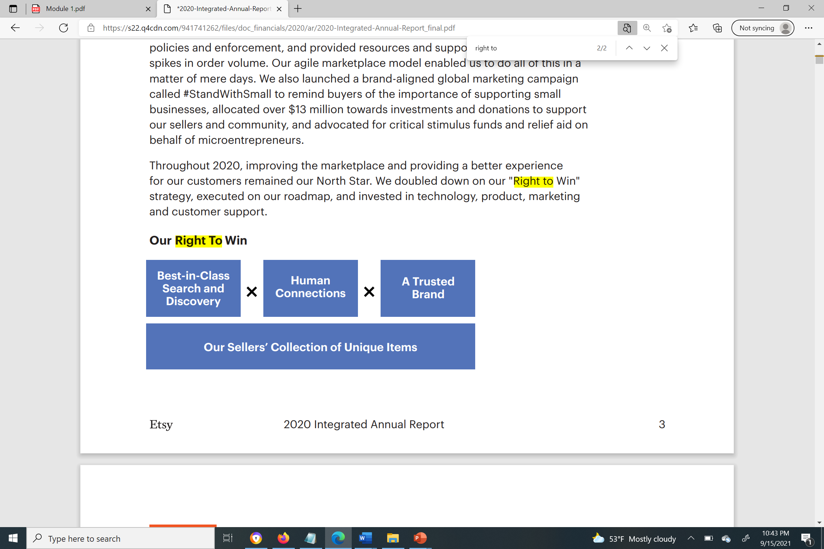

Figure : "Right to Win" Strategy10

## INNOVATION

Innovation strategies are centered on the mechanism that manages the proprietary search algorithms and the website of the company. Etsy’s Research and Development team’s goal is to build dependability by drawing customers to suppliers. However, these innovations are not enough to sustain the business in the long term.

## GROWTH

The firm’s marketplace Reverb had a magnificent 2020, their dynamic business model helped reach high levels of growth and value whilst surpassing the development rate of the musical instruments industry. Etsy delivered remarkable fiscal outcomes—progressing faster than its competitors. Gross Merchandise Sales (GMS) increased by 107% and revenue soared 111%. The firm plans to capitalize throughout the marketing funnel in the latest channels and advances to power regularity and go on to reach more people worldwide. (Etsy, 2020) However, the growth may not be successful as Etsy lacks resources to expand globally and international firms are quite competitive. Countries like China have AliExpress and Wish, those that offer goods low in price and are of decent quality. On Etsy, the buyer has no idea about the quality until the product arrives.

## ALLIANCE

The company does not have alliances but provides an option for sellers to partner with productions to expand their production line. A seller selling a pair of jeans can partner with another seller who sells customized belts. Etsy should consider joining an alliance with courier service companies like FedEx or UPS.

### PEST ANALYSIS

#### Political:

Since Etsy is functional in so many countries, it is subjected to various political factors. The company can face jurisdiction issues if there is a problem with the company's contract. Etsy only sells products that are legal and if sellers are found selling an illegal or counterfeit item, they’ll be subjected to punishment by law. The company also takes measures to protect personal data. The business can be affected by trade policies in certain countries and may have to pay high taxes.

#### Economic:

Etsy benefited from COVID-19 as it generated 2.6 million careers and the sellers contributed $13 billion to the US economy. (Etsy)

#### Social:

Etsy increased their leadership level personnel who classify as an underrepresented minority (“URM”). The company spent over $2.6 million in donations to aid community organizations and programs. (Etsy)

#### Technological:

The interference in technology is high across the industries. Etsy has invested in technologies on its search engine optimizer (SEO) to draw more customers and continues to invest.

# **BUSINESS MODEL EVOLUTION**

Etsy can extend its business by entering a new line of business with its own business model. The company can still have a niche market within this new line of e-commerce, called EtsyPets, for pet products that are handmade. These products shall be hemmed with a tag to create brand recognition. These products shall be made available for wholesalers, resellers, retailers, and individual customers, so they are sold in bulk quantities. Though the products are handmade, there should be mass standard customization. The firm should have brick-and-mortar stores which will increase the profitability of the business. They should also consider non-e-commerce initiatives such as coming up with a social media platform where people can share photos or videos. Although Facebook and Instagram are providing these services, consumers may be willing to migrate due to Facebook’s anti-trust violations.

Etsy can also come up with their own products to increase brand awareness and the existing sellers can be third-party sellers. Another option is that Etsy buys the goods from these sellers and store them by opening its own warehouse.

Etsy should improve its customer service and be more customer-centric to gain the trust of the customers and have more repeat customers. The returns should be made easy and free instead of customers having to talk to the seller first before returning a product. The customers should also be drawn to use their app.

# **BEST IT-SUPPORTED PROPOSAL**

Etsy can have its own social media platform that will draw customers to explore the other platforms from the company. The company will be way more connected to customers and can create brand awareness, which can lead to sales and increased revenue. The data incorporation and organizational skills of the IT department can bring significance to the execution of social media marketing tactics. By improving the promotional strategies, the company will obtain benefits and increase its presence on social media, and IT will contribute to this growth. IT will assist in marketing as well as additional measures to ensure data privacy.

# **CONCLUSION**

Etsy adopts an agile model that helped the business do well even during a turbulent time. The company doubled its profit and performed better than its competitors in 2020. The company believes their recent acquisition, Reverb, will be the base for their future growth. The company has invested in technology and continues to invest and innovate. There are many opportunities for Etsy to expand into new categories of products or a new line of products.

# **REFERENCES**

1. InvestorsObserver. “Will Etsy Inc (ETSY) Stay at the Top of the Consumer Cyclical Sector?” *InvestorsObserver*, 13 Sept. 2021, [www.investorsobserver.com/news/stock-update/will-etsy-inc-etsy-stay-at-the-top-of-the-consumer-cyclical-sector](http://www.investorsobserver.com/news/stock-update/will-etsy-inc-etsy-stay-at-the-top-of-the-consumer-cyclical-sector).
2. Wahba, Phil. “How Etsy Crafted an E-Commerce Comeback.” *Fortune*, 24 July 2019, fortune.com/2019/07/25/etsy-ecommerce-growth-strategies.
3. “04 Jun 2021 Etsy Catapults to Top of ’s Ecommerce Thematic Scorecard Following Depop Acquisition, Says.” *GlobalData*, GlobalData, 4 June 2021, [www.globaldata.com/etsy-catapults-top-globaldatas-ecommerce-thematic-scorecard-following-depop-acquisition-says-globaldata](http://www.globaldata.com/etsy-catapults-top-globaldatas-ecommerce-thematic-scorecard-following-depop-acquisition-says-globaldata).
4. Milnes, Hilary. “The Etsy Guide to Building a Brand.” *Digiday*, 17 Mar. 2015, digiday.com/marketing/etsy-guide-building-brand.
5. “Etsy, Inc. - Investor Relations.” *Etsy*, investors.etsy.com/home/default.aspx. Accessed 15 Sept. 2021.
6. Singh, Tanvir. “Etsy Business & Revenue Model Explained: How Etsy Works & Makes Money.” *JungleWorks*, 23 July 2021, jungleworks.com/etsy-business-revenue-model-explained-how-etsy-works-makes-money.
7. Craftybird. “15 Great Etsy Alternatives for Selling Handmade.” *ToughNickel*, 25 Mar. 2021, toughnickel.com/self-employment/Great-Alternatives-to-Etsy.
8. <https://finance.yahoo.com/quote/ETSY/financials?p=ETSY>
9. [*2020-Integrated-Annual-Report_final.pdf (q4cdn.com)](https://s22.q4cdn.com/941741262/files/doc_financials/2020/ar/2020-Integrated-Annual-Report_final.pdf)

1. Source: GlobalData
2. Source: Etsy.com
3. Source: Yahoo! Finance
4. 7 Source: CNN Business
5. 8 Source: Jungleworks.com | image by Tanvir Singh
6. 9Source: Tough Nickel
7. 10Source: etsy.com